Ref: LD/SH

June 2018

Dear Parent/Carer

Starting at Priory Community School - September 2018

For your information the new Year 7 intake will be starting at PCSA on Monday 3 September 2018. Students should be in school from 8.40am until 11.30am and should wear full school uniform. In order to give them time to settle into their new environment they will be the only year group in school and will spend this time with their tutor groups and familiarising themselves with the school and their new timetables.

As from Tuesday 4 September the whole school will be back and normal school hours will apply from that day onwards - 8.40am to 2.55pm.

I hope you have a fantastic summer. We look forward to welcoming your son/daughter to PCSA in September.

With best wishes.

Yours sincerely
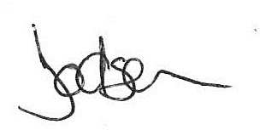
Miss Lee Dodson
Head of Year 7

