Cycle Homelearning
Subject: OCR Sport
Science

Reducing the Risk of Sports Injuries

Learning Outcome 1: Understand different factors which influence the risk of injury.
Learning Outcome 2: Understand how appropriate warm up and cool down routines can help to prevent injury
Extrinsic Factors that can influence the risk of injury
Intrinsic Factors that can influence the risk of injury
Poor posture
Physical & Psychological benefits of a warm up
Key components of a warm up & cool down
Specific needs
Environmental Factors

Expectations
- To complete each task on time for the allocated lesson
- Failure to hand it will lead to an automatic hour detention after school
- HL booklet to be on you in every lesson
Name:

Class:

Teacher:

Extrinsic Factors which can influence the risk of injury.
These are factors outside of the individual that can alter the risk of them getting injured.

Type of
Activity

Coaching /
Supervision

Environmental
Factors

Equipment

Safety
Hazards
- Task 1 – Complete the table to describe the type of injury would expect to see in each sport.
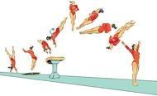 |  | 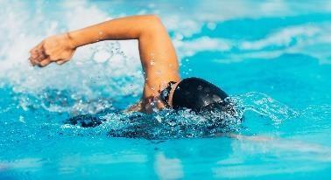 | 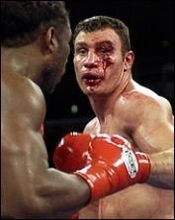
Gymnastics - vaulting | Rugby | Swimming | Boxing
Task 2 – Identify 3 ways a coach or manager could increase the risk of a participant getting injured:

Task 3 – Identify the 3 different categories of environmental factors from the pictures.
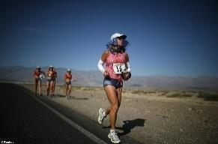 | 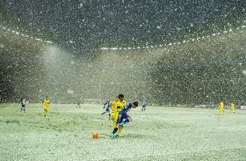 |  |  |  | 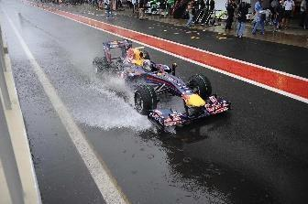
Environmental Factor:
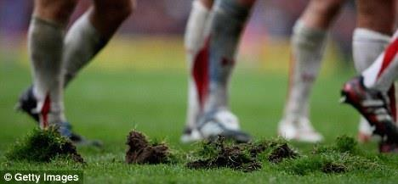 |  | 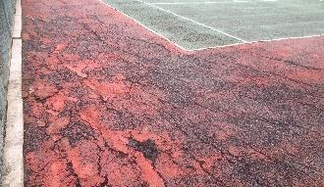 |  | 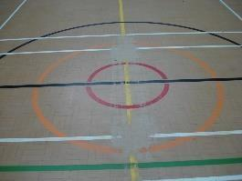
Environmental Factor:
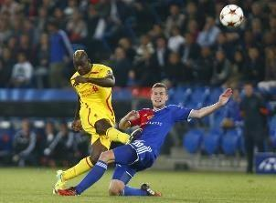 |  |  | 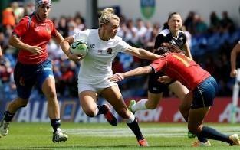
Environmental Factor:

- Task 4 – Complete the table to describe how the equipment can influence the risk of an injury.
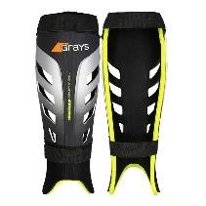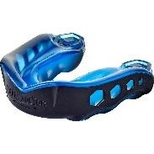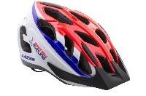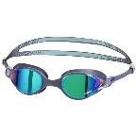 | 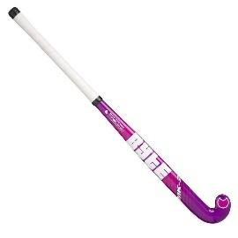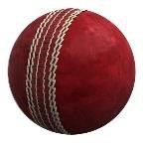 | 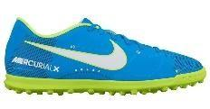  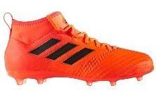
Protective Equipment | Performance Equipment | Suitable clothing/footwear

- Task 5 - Complete the table to describe how each step to reduce hazards can influence the risk of injury.
Risk Assessment | Safety Checks | Emergency Action Plan

Intrinsic Factors which can influence the risk of injury.
These are factors that an individual can take control of which can alter the risk of them getting injured.

Physical
Preparation

Individual
Variables

Psychological
Factors

Posture

Sports Injuries
- Task 6 – Answer the clues to work out the 6 ways that physical preparation can influence the risk of a participant getting injured:
The exercise you do over a period of time to help prepare for an event. | T
The pulse raiser and stretches you do before you start exercising. | W U
The pulse raiser and stretches you do when you have finished exercising. | C D
How fit you are depending on how much training you have been doing. | F L
Working your body or certain muscles too hard without giving them enough time to rest and repair. | O
Overtraining some of your muscles but not training others enough. | M Im

- Task 7 – Consider 6 individual variables between people that could influence the risk of a participant getting injured.
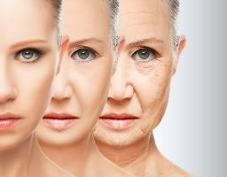
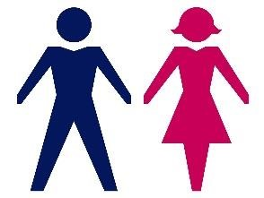
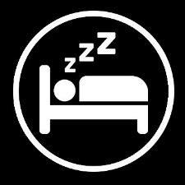
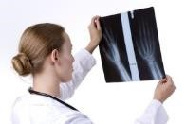
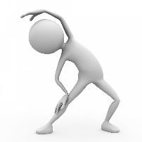

Fle

N

S

G

A

Previous
I

- Task 8 – Consider how the 3 psychological factors could influence the risk of a participant getting injured

Motivation | Aggression | Arousal/Anxiety
The reason for people’s actions. If they are hugely motivated they will put in lots of effort.  If they are not very motivated they will not try very hard. | Hostile or violent behaviour. Some sports have an element of aggression BUT how much is appropriate? | Anxiety - negative emotional state. Arousal - how alert and attentive a performer is.
How could this affect the risk of injury? | How could this affect the risk of injury? | How could this affect the risk of injury?

- Posture is the position you hold your body. Poor posture can impact on the risk of injury.
- Poor stance/gait - hunching shoulders/bending knees.
- Sitting positions – slumping/slouching.
- Physical defects – where muscles have weakened around an injured area.
- Lack of exercise – lack of core muscle strength = less support, overweight = strain on posture.
- Clothing/Footwear – high heels can affect posture.
- Fatigue – tired muscles unable to support the skeleton properly.
- Emotional Factors – low self esteem/lack of confidence can influence posture.

□ Task 9 – Poor posture can lead to specific sports injuries. Write a description for each condition
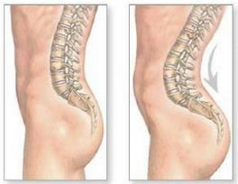 | Lordosis
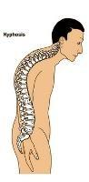 | Kyphosis
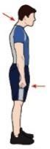 | Round shoulder
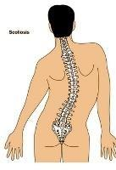 | Scoliosis

Exam Questions
- a) Identify three different extrinsic factors that may influence the risk of injury to a participant in physical activity.
  - (1)

  - (1)

  - (1)

(1) b) Describe each of these extrinsic factors.
  - (1)

  - (1)

  - (1)

- Explain how four individual variables can influence the risk of injury to a sports performer.
  - (1)

  - (1)

  - (1)

  - (1)

- Using practical examples, explain how risk assessments can help to reduce the risk of injuries to participants in physical activity.

(4 marks)
- Using examples, describe two environmental factors that may cause injury to sports performers.

(2 marks)

- A lack of exercise can be one cause of poor posture.
a) Describe four other causes of poor posture

(4 marks)

b) Identify two types of sports injuries related to poor posture

(2 marks)

- Chronic injuries are also known as overuse injuries. Give two examples of overuse injuries in sport.

(2 marks)

Answers

- a) Any three from:
Type of activity or sport
Coaching/Supervision/Poor coaching technique/poor instructions/following rules/refereeing
Environmental factors/weather/playing surface/other participants
Equipment/protective equipment/performance equipment/clothing/footwear Hazards/Risk Assessments/Safety Checks/Emergency Action Plans

b) Description must link to example from part a.
Contact sports present a greater risk of collision injuries (or other relevant examples)
Incorrect coaching technique could lead to a performer carrying out a skill incorrectly which could lead to an injury.
Excessive rain on an outdoor playing area could lead to participants slipping and injuring themselves.
Wearing shin pads in football can reduce the chance of sustaining an injury to the front of the leg. Carrying out a risk assessment before an activity begins ensures that the playing area, participants and equipment are all safe and reduces the risk of an injury.

- Any four from:
Gender - males are generally stronger so less prone to injuries.
Age – older people are generally weaker/more prone to injury.
Flexibility – increased flexibility decreases chance of injury.
Nutrition – drinking enough to water to prevent dehydration/eating enough to avoid fatigue.
Sleep – important we have enough sleep so we are focussed.
Previous injuries – can lead to weak areas that are prone to injury.
Psychological factors – being over aggressive can lead to dangerous tackles.
Individual Physical Preparation – fully warming up can reduce the risk of injury.
Fitness – The fitter we are the less likely we are to get injured (especially towards the end of a game) Behaviour – Not following the rules and being reckless can lead to injuries.
Experience/Ability – being aware of risks to be able to protect yourself. Know how to time a tackle.

3. Any four from (or any other appropriate examples).
Assessing the possibilities of an accident by identifying hazards.
Referee completing a pitch inspection and calling game off if it’s frozen.
Action taken to avoid/prevent/reduce chances of accident.
Removing debris/litter from a tennis court.
Checking/assessing facilities during the activity.
Referee stopping the game due to heavy rain.
Checking/assessing equipment.
Referee checking goal posts.
Checking/assessing participants.
Officials checking if players are wearing jewellery.
Surrounding area/spectators.
Boarding/objects too close to the pitch.

- Any two from
Weather/climate/sun/rain/snow/ice e.g. a wet football pitch would cause players to slip/fall.
Playing surface/potholes/surrounding area e.g players colliding with advertising boards.
Litter/sharp objects/glasss/stones/wet leaves e.g. players could trip on them/cut themselves.
Other participants e.g. being tackled and injured.
Equipment in the environment e.g goal posts/hit in the head by a ball.

- a) Any four from
Poor stance/gait - hunching shoulders/bending knees when walking.
Sitting positions – slumping/slouching.
Physical defects – where muscles have weakened around an injured area.
Lack of exercise – lack of core muscle strength = less support, overweight = strain on posture.
Clothing/Footwear – high heels can affect posture.
Fatigue – tired muscles unable to support the skeleton properly.
Emotional Factors – low self esteem/lack of confidence can influence posture.

b) Any two from
Lordosis
Kyphosis
Round shoulder
Scoliosis

- Any two from
Tendonitis
Tennis Elbow
Golfer’s Elbow
Shin Splints
Repitive Strain Injury Osgood Schlatter Disease

The Physical Benefits of a Warm Up

□ Task 1 – Complete the table to describe why each benefit is important.
Warming up muscles/preparing the body for physical activity
Increase in body temperature
Increase in heart rate
Increase in flexibility of muscles and joints
Increase in pliability of ligaments and tendons
Increase in blood flow and oxygen to muscles
Increase in the speed of muscle contraction

The Psychological Benefits of a Warm Up

□ Task 2 – Match up the reasons with why they are important.
Heighten or control arousal levels  (e.g. ‘get in the zone’ or settle nerves) |  | Helps you forget about any worries/stress that you might have been dealing with before the event. You are solely concentrating on the task in hand.
Improve concentration/focus |  | Help you visualise certain parts of your performance. E.G. Lots of 100m sprinters will visualise themselves running the race from the start position.
Increase motivation |  | Help you achieve an optimum arousal. Not too much that you are ‘over excited’ and not too little that you are not going to try.
Mental rehearsal |  | Helps you improve feelings of wanting to perform well or win.

It’s really important that you know the difference between physical and
psychological. Physical is to do with the changes that happen to the parts of the
body like your heart and muscles. Psychological is to do with changes to your brain and how you are thinking or feeling.

Key Components of a Warm Up

- Task 3 – Number each component so they are in the order you should complete them.
Skill Rehearsal
Mobility
Pulse Raiser
Stretching

- Task 4 – For each component, explain why you should include them in a warm up.
COMPONENT | COMPONENT | COMPONENT | COMPONENT
PULSE RAISER | STATIC STRETCHING | SKILL REHEARSAL | MOBILITY
DEFINITION  Light physical activity like jogging, walking or  swimming. Should take between 5 and 10  minutes and result in a general sweat. | DEFINITION  Placing the body into a position where the muscle or group of muscles is put under tension. | DEFINITION  More vigorous activity which reflect the type of  activity which is required during the session. | DEFINITION  A controlled, soft bounce of swinging motion that  moves a body part to the limit of its range of movement.

The Physical Benefits of a Cool Down

□ Task 5 – Complete the table to describe why each benefit is important.
Helps the body’s transition back to a resting state
Gradually lowers heart rate
Gradually lowers temperature
Circulates blood and oxygen
Reduces breathing rate
Removes waste products such as lactic acid
Reduces the risk of muscle soreness and stiffness
Aids recovery by stretching muscles
Key Components of a Cool Down

□ Task 5 – In the final column add some examples of appropriate activities.
Pulse Lowering | Exercises which gradually lower heart rate and reduce temperature.
Stretching | Exercises which lengthen and stretch muscles for next work out.

Top Tip
–

whenever you refer to a cool down

lowering heart rate
,

you
must

use the word gradually.

Specific needs which a Warm up and Cool Down must consider

- Task 6 – For each characteristic, come up with an example of how it could lead to an increased risk of injury

Size of group

Age of
participants

Experience of
participants

Individual
fitness levels

Medical
conditions of
participants

If the group is
too big for the
space you are
using there is
an increased
risk of injury.
For example if
you have too
many people
warming up on
a badminton
court, someone
could get hit in
the face by a
racquet.

- Task 7 – Environmental factors can effect warm ups and cool downs. Can you match up solutions for each of these environmental factors?
Availability of facilities | During a tournament, netball pitches are being used for games. | A specific area for warm up and cool downs should be provided.
Availability of facilities | Warm up and cool down facilities are poor.
Temperature (too hot) | It is an excessively hot day for a football tournament.
Temperature (too hot) | It is a hot day for a marathon and a number of participants have become dehydrated.
Temperature (too hot) | A rugby game has been played in excessively hot conditions and players have another game in 2 days.
Temperature (too cold) | It is excessively cold and a 100m sprinter has just finished their race.
Temperature (too cold) | After a road race, the cyclists are extremely cold.

Cool down indoors to prevent more heat loss. | Take on even more fluids and refuel after event | Ice baths to help lower core temperature.
Use a longer cool down to ensure cool down is effective. | Warm up and cool down inside or in a shaded area. | Find an alternative/better facility or you will not be able to complete it properly.

Exam Questions

- Describe a suitable cool down for a rugby player.

(2 marks)

- Describe the following key components of a warm up.
a)Pulse Raiser

(1)

b)Mobility

(1)

- Stretching

(1)

- Skill Rehearsal

(1)

- Mental rehearsal can be used as part of a warm up routine. Use a practical example, describe mental rehearsal.
Example
(1)

Description

(2)

- A coach must have knowledge of any medical conditions that participants may have before they warm up. Identify two medical conditions that a coach would want to be made aware of before starting a warm up.

(2)

- Identify four specific needs that need to be taken into consideration when planning a warm up or cool down.

(4 marks)

- Describe four physical benefits of a cool down.

(4 marks)

Answers
- Any two from
Pulse lowering exercise – jogging, light running, light exercises that will gradually reduce heart rate. Stretching – exercise that will lengthen and stretch out muscles that have been used.
Ice Bath
- One mark for each explanation
a) Pulse Raiser
Consist of exercises that slowly/gradually increase the heart rate/increase core body temperature. b) Mobility
Consist of exercise that take joints through their full range of movements.
c) Stretching
Lengthens muscles in preparation for exercise. d) Skill Rehearsal
Practicing actions used in a game/rehearsing common movement patterns/rehearsing specific skills.
- One mark for a relevant example
A gymnast before performing a routine
A 100m sprinter at the start of their race
Two marks for the explanation
Thinking through/visualising/imagining each element of the routine before performing it. Focussing on the event/task and ignoring distractions such as the crowd.
- Two from
Diabetes
Epilepsy
Asthma
Scoliosis
Osgood Schlatter’s
Heart Disease/Heart problems
Allergies (Severe)
DO NOT ACCEPT INJURIES – ONLY MEDICAL CONDITIONS
- Four marks from the following.
Size of group
Age of participants
Gender (mix) of participants
Experience of participants
Individual fitness levels
Injuries/medical conditions of participants
Type of activity involved
Space available
Weather
Time available
- Any four marks from the following.
Gradually lowers/slows heart rate.
Gradually lowers body temperature.
Maintain circulation of blood/oxygen supply.
Gradually decrease breathing rate.
Remove/get rid of waste products/lactic acid. DO NOT ACCEPT PREVENTS LACTIC ACID Reduce risk of muscle soreness/cramps/stiffness.
Decreased risk of injury.
Aid recovery/facilitates participation the next day/prevent fatigue.
Prevents blood pooling
DO NOT ACCEPT PSYCHOLOGICAL – ONLY PHYSICAL

