Cycle 1 Homelearning
Subject: OCR Sport Studies
Year 10

This cycle you are learning about: R053 Sport Leadership
Identifying Different Leadership roles | Week 1
Leadership Qualities | Week 3
Leadership Styles | Week 5
Risk assessment – Risks/Hazards | Week 7
Assessment week (Risk assessment) | Week 8
Superteaching week (Risk assessment review and emergency procedures) | Week 9

Expectations
- To complete each task on time for the first lesson of OCR sport studies of the weeks stated.
- Failure to hand it will lead to an automatic hour detention after school on Wednesday P6 to catch up.
- HL booklet to be with you every OCR sport studies lesson
Name:
Class:
Teacher:

This is Steph Houghton. Identify what kind of sports leadership role she is.  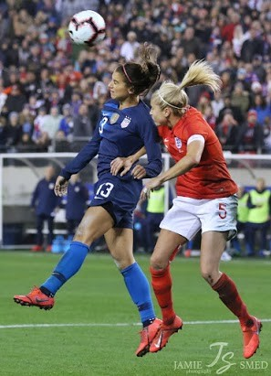  Sports Leadership role: | This is Nigel Owens. Identify what kind of sports leadership role he is. 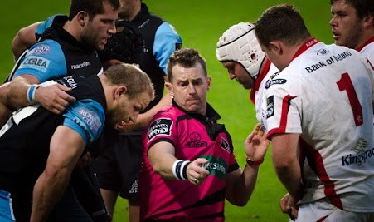Sports Leadership role: | This is Gareth Southgate Identify what kind of sports leadership role he is.  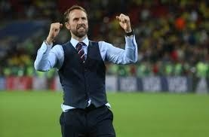  Sports Leadership role:
This is Jessica Ennis-Hill. Identify what kind of sports leadership role she is.  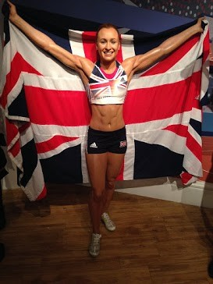  Sports Leadership role: | This is Bear Grylls. Identify what kind of sports leadership role he is.  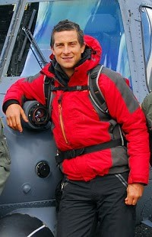  Sports Leadership role: | These are PCSA staff. Identify what kind of sports leadership role they are:  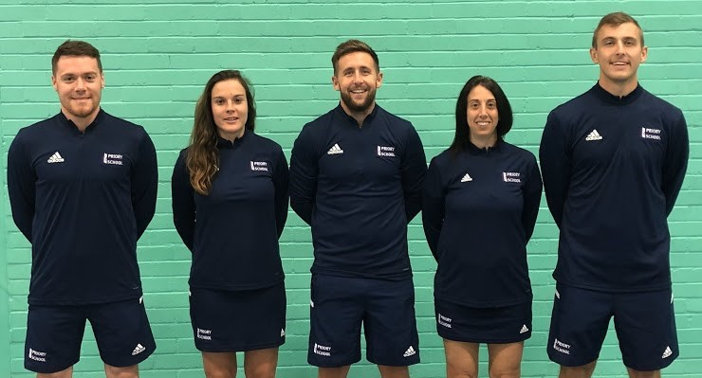 Sports Leadership role:

This is Eddie Jones. Identify what kind of sports leadership role he is.
TASK 2: Can you think of a time where you or someone you know has been one of these sports leadership roles? What sort of qualities did you/they show?
________________________________________________________________________________________________________________________________________________________________________________________________________________________________________________________________________________________________________________________________________________________________________

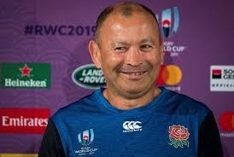

Sports Leadership role:

WEEK 1 – Identifying different Sport Leadership roles
Date due in:
TASK 1: Match the correct sport leadership role to the individual.
They could be any of the following; captain, coach, team manager, expedition leader, PE teacher, sport official or a sporting role model.

________________________________________________________________________________________________________________________________________________________________________________________________________________________________________________________________________________________________________________________________

WEEK 3 – Leadership Qualities
Date due in:
TASK 1: Add in the correct personal qualities that matches the description.

Personal Quality | Description
 | The personal quality that means you are certain of your abilities or have trust in people, plans, or the future.
 | The personal quality that means you are trustworthy or of performing consistently well.
 | The personal quality that means you have the ability to convey or share ideas and feelings effectively
 | The personal quality that means you are consistently on time or early.
 | The personal quality that means you can use your imagination or original ideas to create something or invent something new or different
Role-related responsibility | Description
 | The role related responsibility that means you have good knowledge of how to be protect players within the sport or physical activity to reduce injury.
 | The role related responsibility that means you have good knowledge of the sport or physical activity.
 | The role related responsibility that means you have good knowledge of how to treat injuries that happen in the sport or physical activity.
 | The role related responsibility that means you have good knowledge of the game including fair play, what a foul is, when goals are scored.
 | The role related responsibility that means you have good knowledge of how to keep young people safe within the sport or physical activity.
TASK 2: Add in the correct role-related responsibility that matches the description.

WEEK 3 – Leadership Qualities continued
Date due in:
TASK 3: Identify the personal qualitiies and role related responsibilities these people might need.

Owen Farrell-Rugby Captain  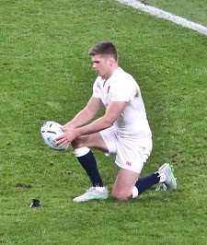 | Personal Qualities | Role-related responsibilties
Ant Middleton-Expedition Leader | Personal Qualities | Role-related responsibilties
PE Teacher | Personal Qualities | Role-related responsibilties
Michelle Joubert-Hockey Umpire  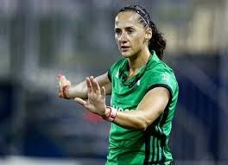 | Personal Qualities | Role-related responsibilties
Mikel Arteta-Manager  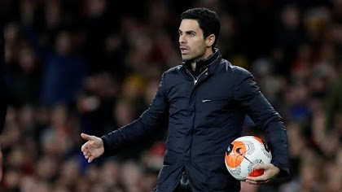 | Personal Qualities | Role-related responsibilties
Serena Williams- Role Model  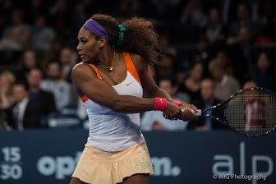 | Personal Qualities | Role-related responsibilties
Chris Silverwood- Cricket Coach  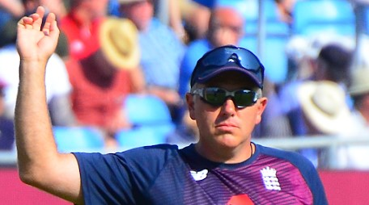 | Personal Qualities | Role-related responsibilties
WEEK 5 – Leadership Styles
Date due in:
TASK 1: Add in these descriptions to fit the correct leadership style.
- Makes all the decisions, takes a direct approach and task orientated, beneficial when decisions need to be made quickly, considers others opinions but still makes the final decision.
- Considers others ideas, takes an indirect approach and person orientated, requires time and knowledgeable participants.
- Provides little support on decisions, takes an indirect approach and delegates, effective when group is highly skilled and motivated.

Leadership Style | Description

Autocratic

Democratic

Laissez-faire
TASK 2: Identify which type of leadership style each of these people would be | Michelle Joubert-Hockey Umpire  Leadership Style:
Ant Middleton-Expedition Leader  Leadership Style: | Mikel Arteta-Manager  Leadership Style:
PE Teacher  Leadership Style: | Serena Williams- Role Model  Leadership Style:
Chris Silverwood- Cricket Coach  Leadership Style: | Owen Farrell-Rugby Captain  Leadership Style:

A | 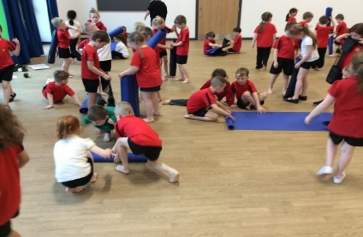  B | 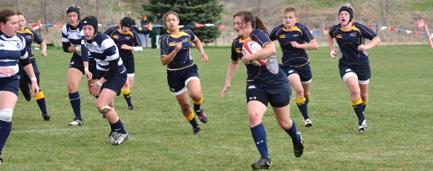  C | 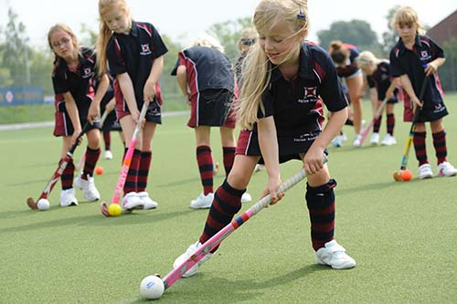  D
Risks | Risks | Risks | Risks
WEEK 7 – Different Risks
Date due in:
TASK 1: Using the pictures, highlight 5 risks/hazards that may take place within the session.

TASK 2: Corrective action.
Definition coloured in:
Purpose coloured in:
Example coloured in:

A coach checking players stud quality before a game of football to ensure safety.
Used to keep participants safe and reduce the risks within the session.
TASK 3: What might the hazard be to the corrective action above?
_______________________________________________________________________________

Action taken to eliminate the potential hazards when delivering a sport session.
TASK 4: Circle the hazards in the picture below.

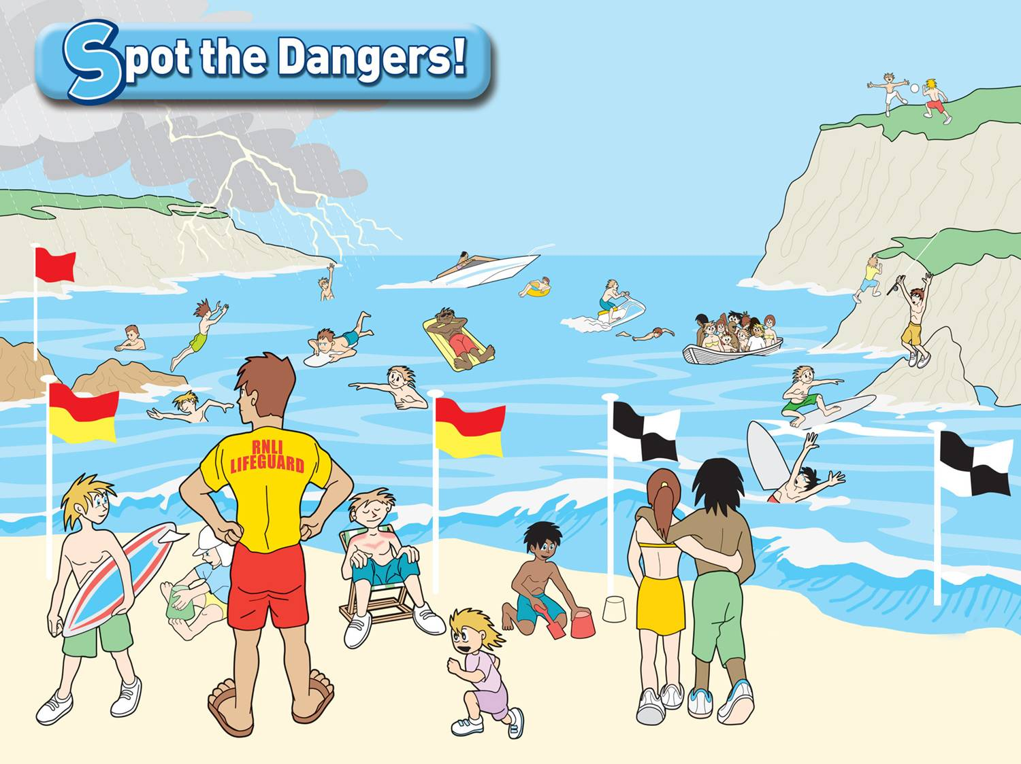

WEEK 8 – Risk Assessment
Date due in:
TASK 1: Identify the order in which you create a risk assessment. Start with the 1st step in the 1st box etc.

TASK 2: Using the risks/hazards identified. Explain what corrective action would be in place to stop this happening in a sports session.

Risk/Hazard | Corrective Action (How you would prevent this happening)
Jewellery getting caught in clothing
Getting long hair caught in equipment
Choking on chewing gum
Dangerous tackles
Long nails causing scratches
Trip hazards within the sports hall/gym
Damage to shins during a tackle in football
Damage to teeth from ball/stick in hockey
The playing surface being uneven, too wet or too slippy
Litter causing danger and trip hazards
Extreme weather conditions (hot or cold)
TASK 3: Identify the 4 emergency procedures you would need to describe in your risk assessment.

1.___________________________________
2.___________________________________
3.___________________________________
4.___________________________________

WEEK 9 – Risk assessment review and emergency procedures
Date due in:
TASK 1: Review your risk assessment you have created as part of your assessment. Have you included the following:
- General information (activity, facility, participants)
• Identify potential risks
• Severity of that risk (low, medium, high or 1 - 5)
• Probability of the risk (low, medium, high or 1 - 5)
• Corrective action
How could you improve your risk assessment?
________________________________________________________________________________________________________________________________________________________________________________________________________________________________________________________________________________________________________________________________________________________________________________________________________________________________________________________________________________________________________________________________________________________________________________
________________________________________________________________________________________________________________________________________________________________________________________________________________________________________________

TASK 2: What would you do if these emergency procedure situations happened in your session?
1. A fire drill occurs
__________________________________________________________________________________________________________________________________________________________________________________________________________________________________________
2. A participant fractures their arm
__________________________________________________________________________________________________________________________________________________________________________________________________________________________________________
3. A participant gets a contusion from getting hit/knocked by equipment __________________________________________________________________________________________________________________________________________________________________________________________________________________________________________
4. A participant has an asthma attack
_____________________________________________________________________________________________________________________________________________________________________________________________________________________________________________________________________________

