Cycle 1 Homework
September 2020

Subject:
Computer Science
Year 7

This cycle you are learning: Basic ICT Skills, Google Apps and E-Safety.

What you will learn | Week
Basic ICT Skills – Passwords/Logging on | 1
Being a responsible digital citizen | 2
Keyboard Shortcuts and Google Apps | 3
Collaborative working using Google Apps | 4
Using email, phishing emails | 5
Social Media – staying safe | 6
Revision | 7
Assessment | 8
Super Teaching Week | 9

Expectations
- Complete 3 homework tasks per cycle.
- Complete 1 week of revision based homework per cycle ready for week 8.
- Your homework will be marked online or in class (peer assessment).
- It must be completed by the due date or you will receive an automatic detention.
Rationale for home work this term:
- To learn new skills to prepare you for the ICT classroom
- You should spend a minimum of 30 minutes practicing the skills
- The website has a number of tasks for practicing typing, you may do any of these in addition to the set work to improve your skills
- If you do not have access to a computer or laptop at home then you can use a computer at school; either in the library or in a computer room (make sure you ask for permission from a computing teacher).The computers are available for use before tutor time, at break time or during P6.

Name ______________________
Teacher ____________________

Task 1: Week 1 – Starting on your typing skills

Due: Week 3 Date: ___________________

Success criteria: Assessment method:
Complete each of the typing skills Online assessment / Teacher check

TASK:
On a computer or laptop (not a tablet or phone) go to https://www.typing.academy/typing-tutor/lessons. Complete the tasks from the image below. Each one is two minutes long, but you can attempt each one as many times as you like. Once finished write down your scores in the table below.

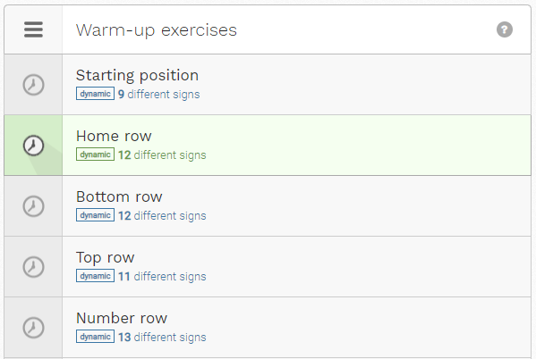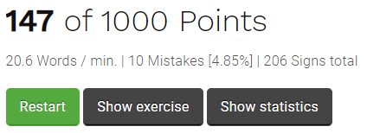

Exercise | Points score | Words/min | Total mistakes | Total signs
Starting position
Home row
Bottom row
Top row
Number row

WWW:___________________________________________________________________

EBI:_____________________________________________________________________

Task 2: Week 3 – Combining the rows

Due: Week 5 Date: ___________________

Success criteria: Assessment method:
Complete each of the typing skills Online assessment / Teacher check

TASK:
On a computer or laptop (not a tablet or phone) go to https://www.typing.academy/typing-tutor/lessons. Complete the tasks from the image below, they are in the warm up exercises section. Each one is two minutes long, but you can attempt each one as many times as you like. Once finished write down your scores in the table below.

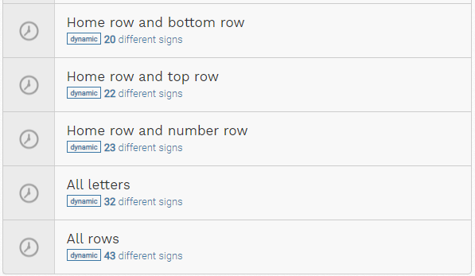

Exercise | Points score | Words/min | Total mistakes | Total signs
Home row and bottom row
Home row and top row
Home row and number row
All letters
All rows

WWW:
____________________________________________________________________

EBI:
____________________________________________________________________

Task 3: Week 5 – Improving your typing

Due: Week 7 Date: ___________________

Success criteria: Assessment method:
Complete each of the typing skills Online assessment / Teacher check

TASK:
On a computer or laptop (not a tablet or phone) go to https://www.typing.academy/typing-tutor/lessons. Complete the tasks from the image below, these are located under the Hands-on lessons section. Each one is two minutes long, but you can attempt each one as many times as you like. Once finished write down your scores in the table below.

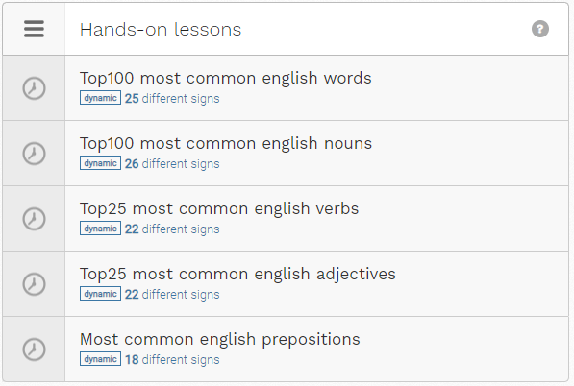

Exercise | Points score | Words/min | Total mistakes | Total signs
Most common English words
Most common English nouns
Most common English verbs
Most common English adjectives
Most common English prepositions

WWW: ____________________________________________________________________

EBI:_______________________________________________________________________

Task 4: Week 7 – Revision Time

Due: Week 8 Date: ___________________

Success criteria:
- Using your knowledge organiser to help; create a mind map of all the topics we have covered in this unit.

Assessment method:
- Assessed through the end of unit assessment

