Cycle 2 Homework
Subject: OCR Sport Studies

Year 10

This cycle you are learning about: R053 Sport Leadership
Designing a session plan outline | 1
Elements of an effective session plan | 3
Risk assessment – identifying potential risks | 5
Risk assessment – corrective action | 7
KNOWLEDGE ASSESSMENT | 8
SUPERTEACHING | 9

Expectations
- To complete each task on time for the Wednesday P1 of that week
- HL booklet to be on you in every OCR sport studies lesson
Name:
Class:
Teacher:

WEEK 1 – Designing a session plan outline
TASK 1 – Use a either IDENTIFY, APPLY OR CONSISTENTLY APPLY to fill in the blanks for the Bronze, Silver and Gold objectives
SILVER – TBAT __________________ football passing skills in a practise situation
BRONZE – TBAT _________________ a range of teaching points associated with shooting in netball
BRONZE – TBAT ________________ a suitable structure and formation to create an effective attack in hockey
GOLD – TBAT ________________ dribbling skills to a game situation in basketball
SILVER – TBAT _____________ the teaching points of an over head clear in badminton

TASK 2 – Write a set of B,S,G objectives for either of the following skills (passing in handball, close catching in rounders/cricket, throwing in dodgeball or shooting in Hockey)
BRONZE

SILVER

GOLD

WEEK 3 – Elements of an effective session
An effective sport session includes a variety of key considerations
TASK – Using a number system or colour code, match the considerations (left) to the definitions (below)

- Objectives of the session
- Appropriate venue
- Equipment needs
- Supervision needs
- Timing of activities
- Introduction/conclusion of session
- Basic warm up
- Basic cool down
- Skills and technique development
- Engaging
- Organisation

Strategies to make it fun, competitive and challenging for all levels of ability. Helps to keep participants motivated
At any point of the session, do you need an assistant coach or teacher to help? How could they be best used?
The use of Bronze, Silver and Gold to allow all abilities to achieve success

Indoors vs outdoors
Grass vs tarmac
The main focus of the session, where progressive drills and activities are used
Helps to lower the heart rate gradually and allows for the fatigued muscles to recover
Involves a fun pulse raiser with dynamic stretches
A detailed section explaining what kit is required at what stage of the session
Considerations given to how long each task should approximately last for
Being punctual to the session to set up all the necessary equipment. Use of diagrams in the session plan will assist with this
A group brief at the beginning and end to outline the session. A brilliant opportunity to outline and review the learning objectives
WEEK 5 – Risk Assessment: identifying potential risks
A B
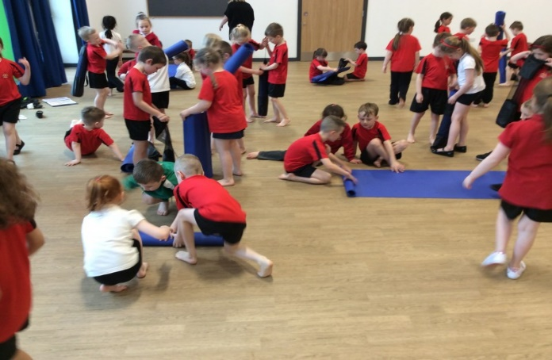
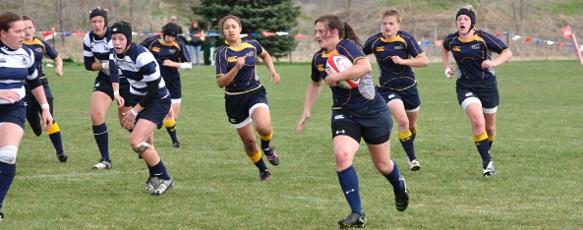

C D
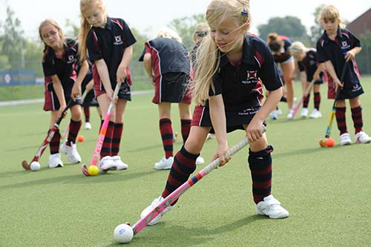
TASK – using the pictures, highlight 5 aspects of danger/risk that may take place within the session?

- Picture___ because __________________________________________ ___________________________________________________________
- Picture___ because __________________________________________ ___________________________________________________________
- Picture___ because __________________________________________ ___________________________________________________________
- Picture___ because __________________________________________ __________________________________________________________
- Picture___ because __________________________________________ ___________________________________________________________
WEEK 7 – Risk Assessment: corrective action
TASK 1 – Match the correct definition, example and purpose for corrective action within a sports risk assesment
PURPOSE
Action taken to eliminate the potential hazards when delivering a sport session
EXAMPLE
Used to keep participants safe and reduce the risks within the session

DEFINITION
A coach checking players stud quality before a game of football to ensure safety

TASK 2 – using your safety aspects from week 5 (previous page), can you explain what action would be taken by a coach to reduce that risk?
1)__________________________________________________________________________________________________
2)__________________________________________________________________________________________________
3)__________________________________________________________________________________________________
4)__________________________________________________________________________________________________
5)__________________________________________________________________________________________________

