OCR Cambridge Nationals
Sports Science Unit R041
LO3 Revision Guide
Reducing the Risk of Sports Injuries

Learning Outcome 3: Know how to respond to injuries within a sporting context.

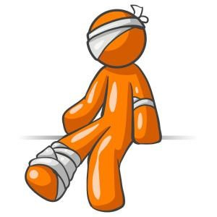

Acute and Chronic Injuries

- Task 1 – Fill in the gaps using the words from the box.
immediate | overuse | sudden | gradually | function | continuous

Acute injuries are caused as a result of a trauma to the body.
They result in pain.
They usually result in a lot of swelling and a loss of .
Chronic Injuries are also known as injuries.
They are the result of stress to an area.
They tend to develop over a period of time

- Task 2 - In the Venn diagram list as many acute and chronic injuries as you can.
Acute
Chronic

Types, causes and treatment of common sports injuries
- Task 3 – Complete the table to identify causes and treatments of common injuries
Injury | Picture | Symptoms | Treatment
Soft Tissue Injuries | 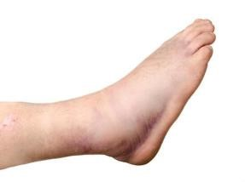 | Result in swelling/bruising
E.G. Sprains/Strains
Overuse Injuries | 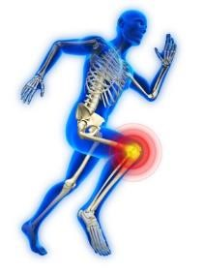 | Caused by repetitive trauma.  Gradual onset of pain.  Stiffness.
E.G. Tendonitis/Tennis Elbow/Shin Splints
Aching.
Swelling.
Fractures | 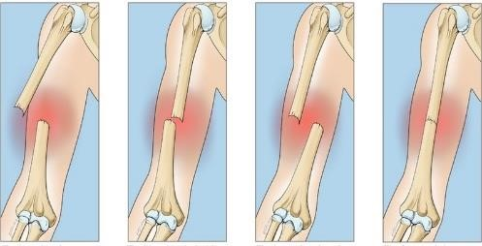 | Immediate pain.  Unable to move.  Disfigurement of limb.
E.G Open/Closed/ Displaced/Non Displaced
 |  | Open – bone breaking through the skin.
Concussion | 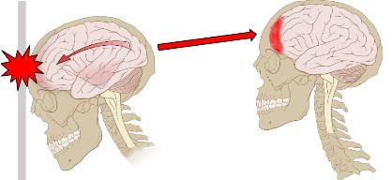 | A head injury with temporary loss of brain function.  Headaches/trouble
E.G. Signs and Symptoms
 |  | with memory/blurry vision/nausea.
Abrasion | 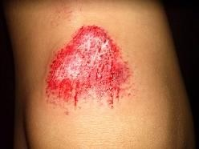 | Split skin.  Blood seeping out of
E.G. Grazes and Cuts
 |  | area.
Contusions | 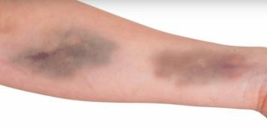 | Bleeding under the surface of the skin. Discolouring of an
E.G. Bruises
 |  | area or skin.
Blisters | 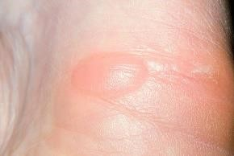 | Red, raised skin. Painful to touch.
E.G. Different parts of the body
Cramp | 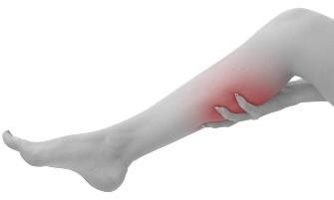 | Painful sensations caused by muscles contractions or over shortening
E.G. Different parts of the body

How to respond to injuries and medical conditions in a sporting context
- Task 4 - Complete the bottom chart to work through an example (Use QR code for extra help).

See
Ask
Look
Touch
Active
Passive
Strength
you’ve seen
the injury
happen
ask
questions
about the
injury e.g.
where, how
painful
look for
specific
signs of
injury e.g.
blood,
dislocation
gently touch
the area to
identify
swelling or
areas of
pain
ask them to
move the
injured part
on their own
you move
the injured
part
get them to
place
pressure on
injury e.g.
standing up
A player
goed down
after a bad
tackle to the
left ankle.
Top Tip
–

when assessing an injury and a participant cannot do
the next stage of SALTAPS you must STOP.

If they can do all of this, it is time to consider how to treat them.

- Task 5 - Identify the word for each stage of the R.I.C.E. procedure (Use QR code for extra help).

R
Get them to rest
and not used the
injured part
I
Apply ice to
reduce swelling
C
Help support and
reduce swelling
E
Lift the injured
part above the
heart to reduce
blood flow and
swelling
Top Tip
–

You would not use RICE for a serious injury (E.G. a
fracture) where a participant is unable to move the injury. This
could cause further damage.

- Task 6 - Fill in the gaps to describe how stretching and massage can help aid recovery.
Stretching | If the performer has pulled a muscle, they will need to get the muscle to relax and stretch it back to its normal self using active and passive stretching. | This will increase to promote healing and remove products such as lactic acid.
Massage  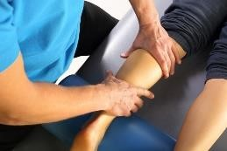 | Massage helps promote blood flow to the targeted area which can help healing as well as relaxing the injured area. | It helps to waste products such as acid, reducing stiffness.

- Task 7 - To stop an injury become worse, further support can be provided in the following ways. Match the picture to the correct name.

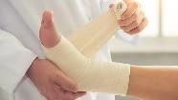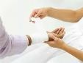 |  | Taping | Taping the area to keep it rigid and structured, reduce movement.
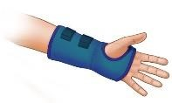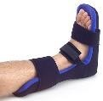 |  | Bandaging | Wrapped around the area to support and reduce swelling.
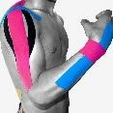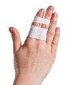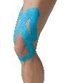 |  | Slings | Reduce load and movement allowed.
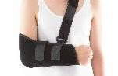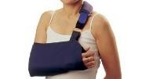 |  | Splints | Keep the part very rigid and unable to move.

- Task 8 - Fill in the gaps to describe how hot and cold treatment can aid recovery.
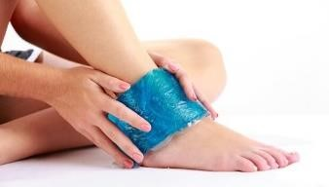  Ice | Used for acute injuries | Apply the cold for 20 minutes at a time and repeat every few hours. | the pain the blood flow. the swelling.
Heat  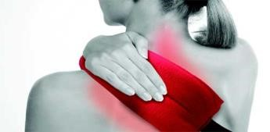 | Used for chronic injuries | Apply for 20 minutes.  Do not repeat. | relax. blood flow. pliability of muscles, tendons and ligaments.

Emergency Action Plans (EAP) in a sporting context.

Sports clubs/events/venues need to have a plan in place ready in case of a
serious injury or incident. They need to know what to do if something happens.
Without this response a person could be put at greater risk.

- Task 9 - Can you identify the Emergency Personnel that could be identified in an EAP?
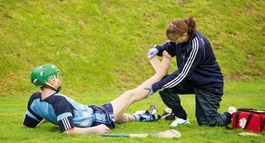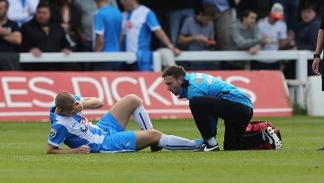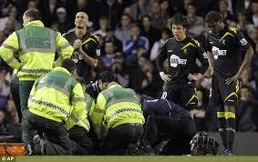

A Carry Primer |  | Designated people  Must hold a relevant up to date qualification.  React to injury and start treatment process.
Raised Rift
Achoc
Therapy Istiophs
Friedn Presorts

The size of the event/venue will determine the amount of emergency personnel.
At a premier league football match their will be significantly more than at a
game of U10’s local football.

- Task 10 - Can you identify the Emergency Communication that could be identified in an EAP?
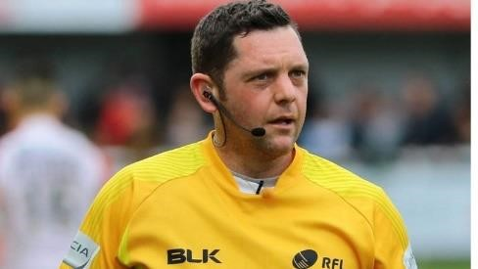 | 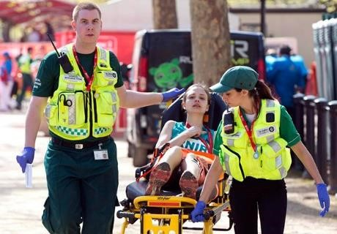 | 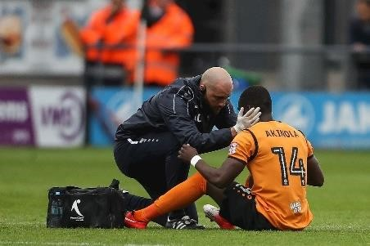
Referee using | First Aiders using | Physiotherapist using
There must be a way of communicating either to get the emergency personnel or the emergency services.
This is important as depending on the situation it may require more people, equipment to be brought out, or at worst an ambulance.
On the plan there will also be emergency numbers to contact.

- Task 11 - Can you identify the Emergency Equipment that could be identified in an EAP?
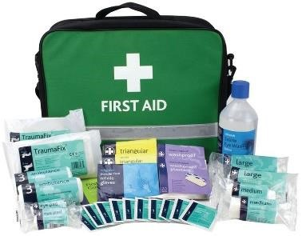 | 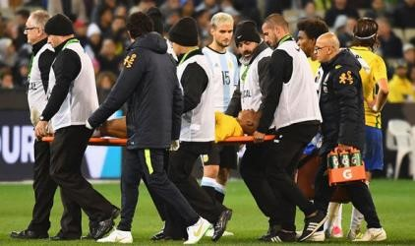 | 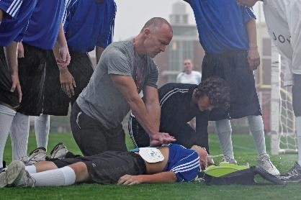
You need to have the appropriate equipment to be able to treat and respond to injuries. E.g. a first aid kit, stretcher, evacuation chair for if you need to get them down or up steps etc.
Again this is vitally important as you need to have the correct tools to be able to treat the injury or start the treatment process while further help arrives.

Use the QR
code to watch a video where different aspects of an EAP

come into force. Can you spot SALTAPS being used as well?

Case Study
Name: Fabrice Muamba
Date: 17th March 2012
Location: White Hart Lane

Details
•
Muamba was playing football for Bolton Wanderers against Tottenham Hotspur.
•
43
minutes into the game Muamba collapsed.
•
Rafael van der Vart (a Spurs player) noticed and signalled to the pitch side medical teams to come to help.
Emergency
Personnel
•
Spurs had 5 fully medically trained assistants on pitch side and
the St John Ambulance Unit.
•
Medical Staff began to administer CPR.
•
A doctor (a heart specialist!) from the crowd persuaded stewards to let him on the pitch to help.
Emergency
Communication
•
The physiotherapist had a head set on and could communicate with other team personnel.
•
An ambulance was called.
Emergency
Equipment
•
Muamba received 2 defibrillation shocks on the pitch.
•
Muamba was carried off the pitch on a stretcher to the tunnel
.

Further incidents:
- The referee called the game off.
- Down the tunnel, Muamba received another defibrillation shock whilst they waited for an ambulance.
- There were a number of medical professionals present: Tottenham’s Club Doctor, 2 paramedics, Bolton’s Physiotherapist, Bolton’s Club Doctor, The doctor from the crowd.
- The doctor from the crowd persuaded the ambulance men to go to a different hospital. They had planned to go to the nearest, but the doctor persuaded them that Muamba needed the specialist equipment at a hospital 8 miles away.
- During the ambulance journey Muamba received 12 more defibrillation shocks and continued to receive CPR.
- Once in the hospital Muamba continued to receive treatment and finally regained consciousness on the Monday – 2 days later.

Use the QR code to watch a video
of the incident. Although you can’t

see specific details, when you watch it with the case study information, you

can see how the Emergency Action Plan was

used to save Muamba’s life.

Exam Questions
- Give one example of each one of the following common sports injuries
Type of Injury | Example of type of injury
Soft Tissue Injuries
Overuse Injuries
Fractures
Abrasions
Contusions
(5 marks)
- Which one of the following is not a suitable response when dealing with a muscle strain?
  - Heat Packs
  - Bandaging
  - Elevation
  - Ice Packs
(1 mark)

- Explain the R.I.C.E..method when dealing with a soft tissue injury.

(4 marks)

- a) Identify one acute injury and describe why it is an acute injury

(3 marks)
b) Identify one chronic injury and describe why it is a chronic injury

(3 marks)
- Describe two possible causes and one suitable treatment for blisters.

(3 marks)
- Tendonitis is a common sports injury. Complete the following table below to show the type of injury it is, one symptom of it and its treatment.
Injury Type | Symptom | Treatment
(3 marks)
- Debbie is training for a marathon and is running 50KM per week. Identify three possible injuries that she may experience as a result of her training and what might have caused each of them.
Injury 1: (1)
Cause: (1)

Injury 2: (1)
Cause: (1)
Injury 3: (1)
Cause: (1)
- Which one of the following does the term R.I.C.E. stand for?
  - Reassurance, Ice, Compress, Emergency
  - Rest, Ice, Compress, Elevate
  - Rest, Insulin, Cold, Emergency
  - Response, Ice, Compress, Elevate
(1 mark)

- Which one of the following does the term S.A.L.T.A.P.S. stand for?
  - See, Ask, Look, Touch, Active, Passive, Strength
  - Search, Ask, Look, Touch, Active, Passive, Strength
  - See, Ask, Look, Touch, Action, Passive, Strength
  - See, Ask, Look, Touch, Action, Passive, Success
(1 mark)
- All sporting clubs have a responsibility to and duty of care to ensure a safe environment for participants and spectators and this is often highlighted in their Emergency Action Plan (EAP)
Identify three different components of an Emergency Action Plan
1.
2.
3.
(3 marks)

Answers

- Accept one for each
Soft Tissue Injuries | Sprain/Strain/Tearing/Twisted ankle/brusing/pulled muscle
Overuse Injuries | Tendonitis/Tennis Elbow/Golfer’s elbow/Shin Splints
Fractures | Open/Closed/ Broken limb/chipped bone/cracked bone
Abrasions | Grazes/Cuts
Contusions | Bruises/Hematoma

- A Ice Packs
- Four marks from:
R - Rest the injured part/stop the activity/don’t put your weight on it.
Use crutches/Use splints/putting feet up/continued activity can cause further harm/injury.
I – Apply ice
15/20 minutes every 2/3 hours to stop internal bleeding/reduce swelling/relieve pain.
C – Compress
Bandage the injured area to prevent swelling/movement or to stop/control bleeding or to support/protect. E – Elevate
Above level of heart/keep leg up/keep limb up to reduce swelling/pain/blood flow.

Answers must include a description of ‘how’ or an explanation of ‘why’.

- a) Acute Injuries
One mark max for example:
Acute injuries such as sprained ankle, strained back, fractured hand, strain, sprain, concussion (or any other example that happens suddenly during an activity).
Two marks max for description
Caused as a result of a sudden trauma or blow to the body. Immediate pain.
Immediate swelling
Immediate loss of function/weakness b) Chronic Injuries
One mark max for example:
Chronic injuries such as tendonitis, shin splints, tennis elbow, golfer’s elbow (or any other relevant example)
Two marks max for description
Overuse injuries/result of continuous stress on an area.
These injuries tend to develop gradually over a period of time.
Resulting in pain.
Swelling over a period of time.
Lasts a long time or keep recurring.
Gradual loss of function or increase in weakness.

5. Any two marks for a reason from:
Caused by friction/rubbing from footwear/poorly fitting footwear/inappropriate footwear/new footwear.
No socks/inappropriate socks.
Heat/hot weather.
Sweating/wet feet.
Large amounts of stress/impact/overtraining/overuse/long distances. Not used to the training.
Any one mark for a treatment
Sterilise/clean/disinfect/use cream.
Leave the blister to heal/intact.
Cover/Put a plaster on/Put a dressing on.
If signs of infection seek advice.
Puncture with sterilised needle.
Apply ice pack to blood blisters.

6. Injury type (one mark from the following)
Overuse injury
Chronic injury
Soft Tissue injury
Symptoms (one mark from the following)
Pain/soreness in the area where the tendon is
Inflammation
Swelling
Treatments (one mark from the following)
Rest
Ice Pack
Taping/Bandaging
Mobility Exercises
Ultrasound
RICE
Anti-inflammatory medicine

- One mark for each injury and one mark for each correctly identified cause.
  - Shin Splints or stress fracture
Caused through overuse, too much running on hard surfaces/incorrect footwear.
  - Fractures
Caused by falling.
  - Blisters
Caused by ill-fitting footwear or clothing e.g. Wearing a new pair of trainers for a long run without breaking them in/ over use.
  - Cramp
Caused by muscular contraction- lack of fluids/minerals in body or poor hydration.
  - Abrasions/Cuts
Caused by falling/tripping over.
  - Contusions/Bruises
Caused by falling/tripping over.
  - Tendonitis
Caused by overuse.
  - Sprain
Caused by going over on your ankle.
  - Strain
Caused by not being fit enough/doing too much at once/not warming up properly.
  - Concussion
Caused by falling/tripping over and banging head/colliding with something.

- Which one of the following does the term R.I.C.E. stand for?
B. Rest, Ice, Compress, Elevate

- Which one of the following does the term S.A.L.T.A.P.S. stand for?
A. See, Ask, Look, Touch, Active, Passive, Strength

- Any three marks from:
Emergency personnel (accept named person e.g. first aider/coach/first respondent)
Emergency communication (telephone/emergency telephone numbers/emergency services) Emergency equipment (accept named examples e.g. first aid kit/defibrillator/stretcher)

8 Mark Question Practice
Describe how SALTAPS can be used to respond to injuries and medical conditions.
(8 marks)

Intro paragraph – What is SALTAPS? What does it stand for? When is it used?
What are the different sections of SALTAPS and what do they involve?

TIP

1
:

Could
you use an
example to
demonstrate
how SALTAPS
would be
using in a
sporting
context?

Are there any incidents when SALTAPS should stop?

Sum up your overall comments

TIP 1:
Can you
think of the
next step once
SALTAPS has
been
completed?

Push yourself because no one else is going to do it
for you
!

Good Luck with your exams
☺

