

**Homework**

**Subject: Design**

**Cycle 2**

**This cycle you are applying Numeracy & Literacy**

**skills in Design**

**Year 7**

**Expectations**

**Complete 4 homework tasks per cycle (or the equivalent time if doing a longer project).**

**Complete 1 week of revision based homework per cycle ready for week 8.**

**Your homework will be marked by a mix of peer, self and teacher assessment.**

**Rationale for home work this term:**

**To consolidate in class learning**

**To secure your knowledge of key topics**

**To practice skills related to your assessment**

**Name ______________________**

**Teacher ____________________**

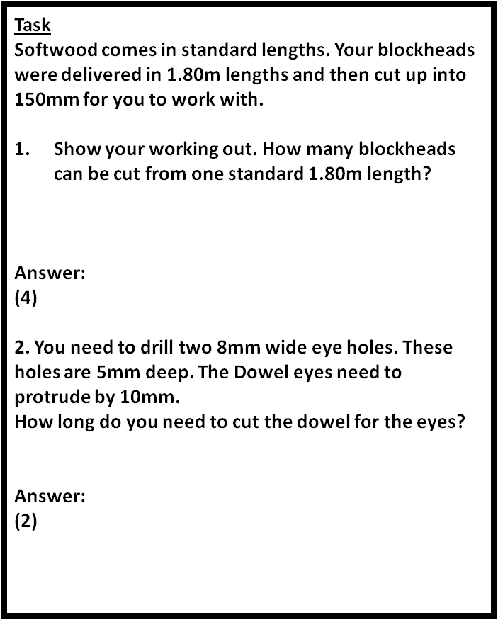

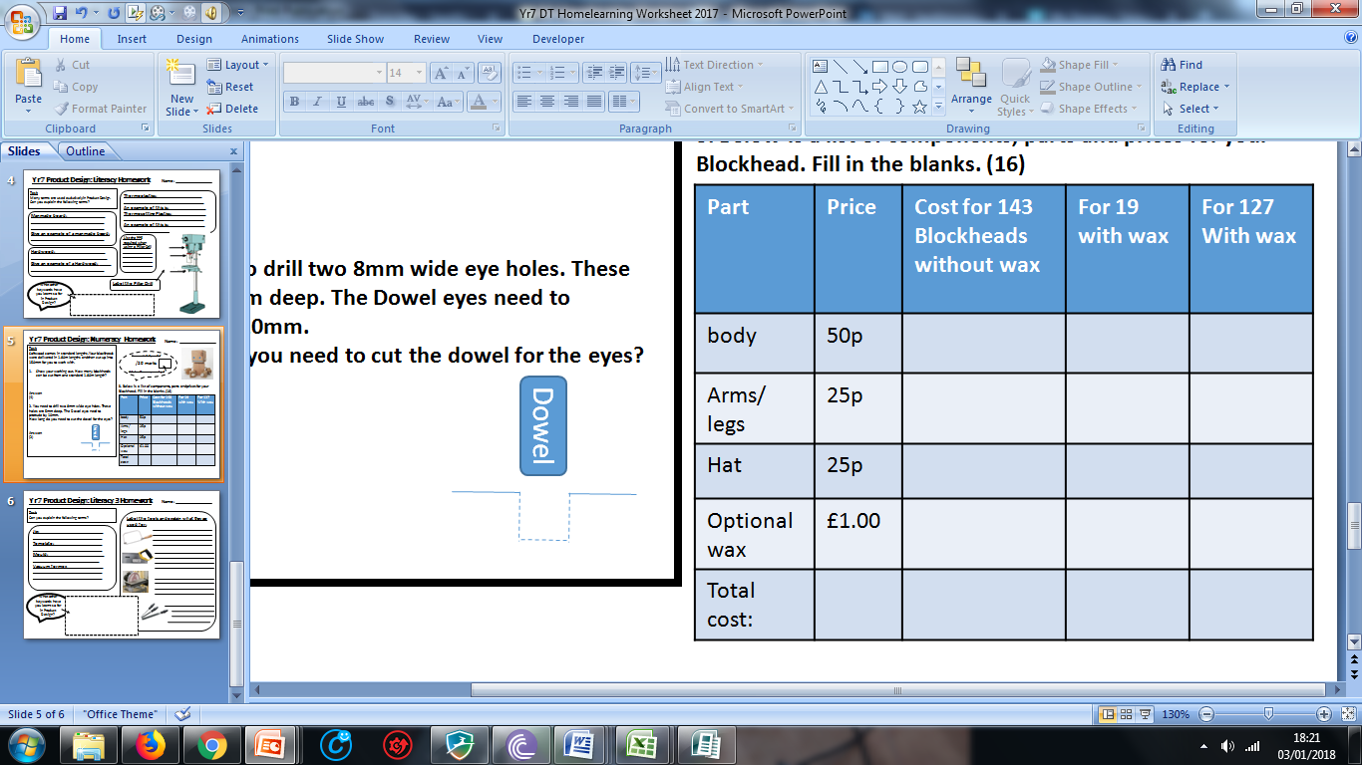

**Date due:**

Show your working out below:

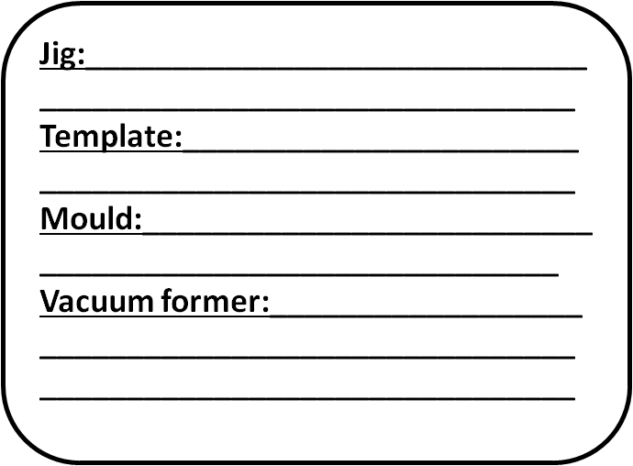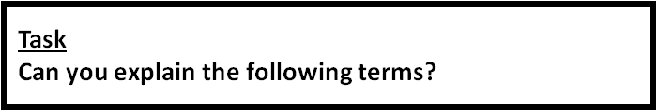



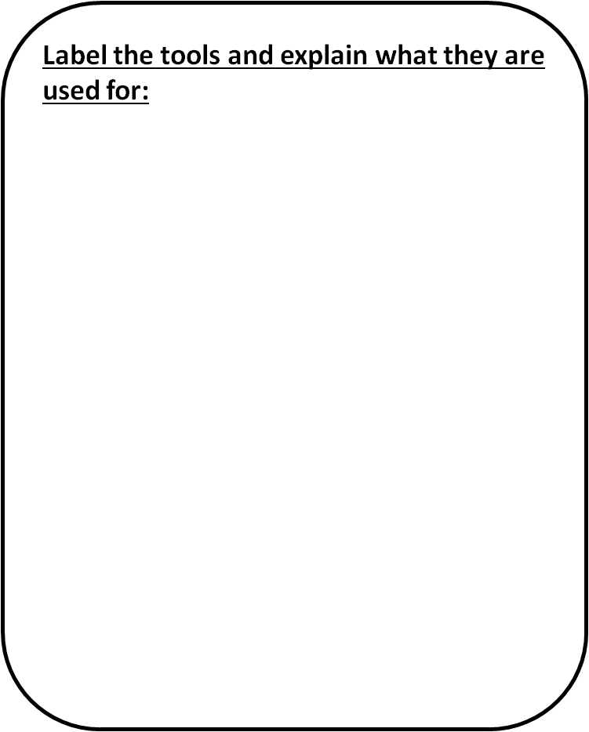

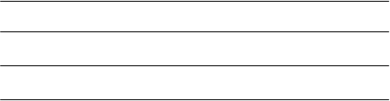

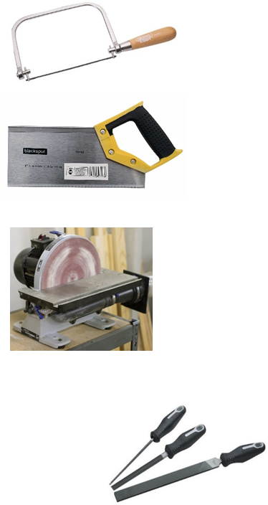







**Date due:**

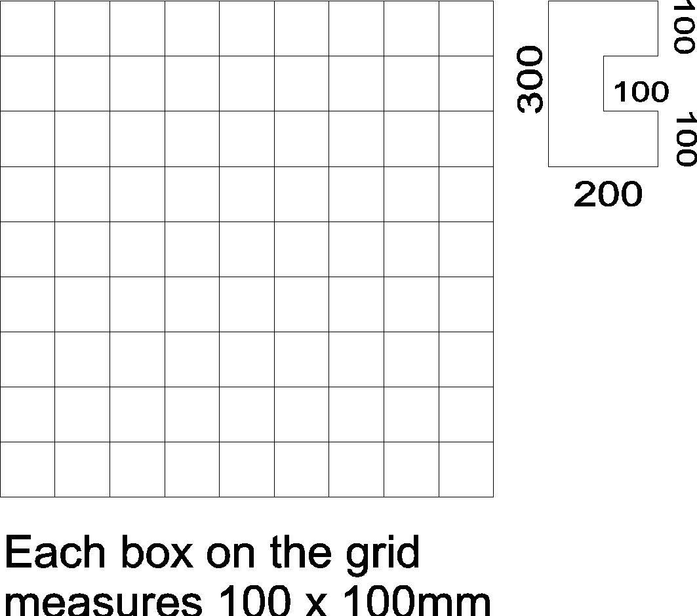

Using the shape shown to the right of the grid. How many times can the shape fit into the grid.

Draw the shape repeatedly on the grid to work out.

**Date due:**



**Date due:**

Make a 5 question quiz on this week’s lessons for your peer.

Make the questions quite hard, include the answers (in Brackets) on your quiz.

1.

2.

3.

4.

5.

Teachers comment:

Student feedback comment: