

**Homework Subject: Design Cycle 2**

This cycle you are applying Numeracy & Literacy skills in Design

**Year 8**

Expectations

Complete 4 homework tasks per cycle (or the equivalent time if doing a longer project).

Complete 1 week of revision based homework per cycle ready for week 8. Your homework will be marked by a mix of peer, self and teacher assessment.

Rationale for home work this term: To consolidate in class learning

To secure your knowledge of key topics

To practice skills related to your assessment

# Name Teacher

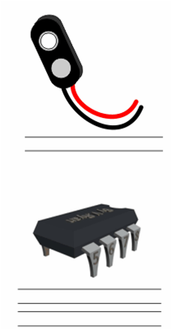

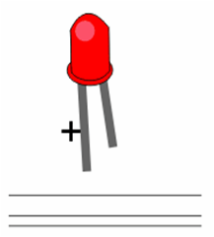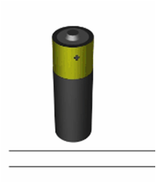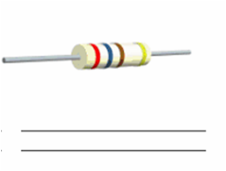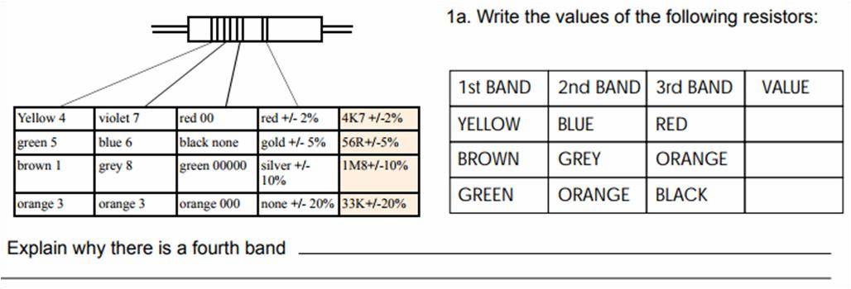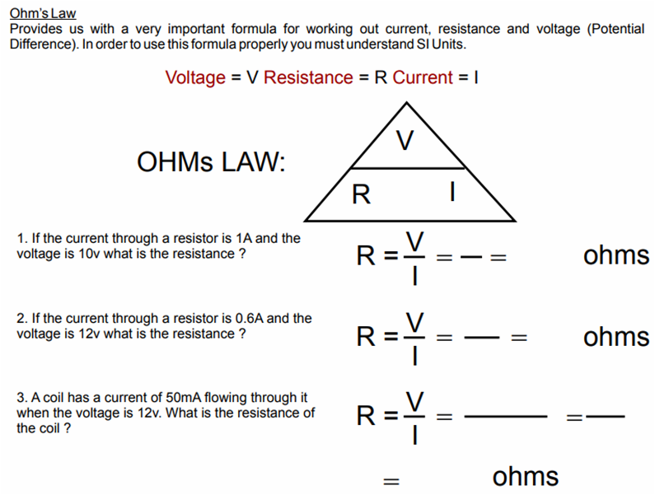

**Date due:**





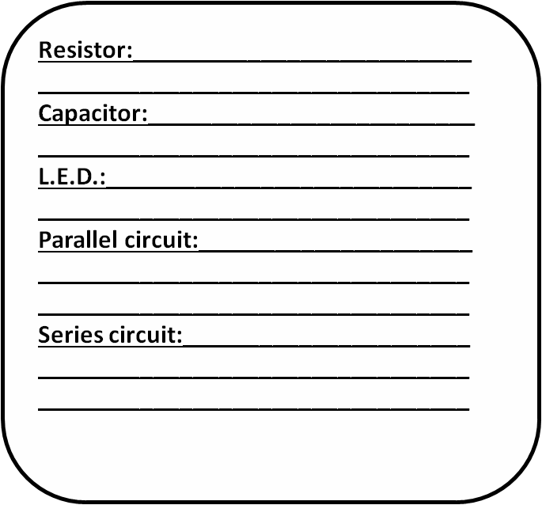

**Date due:**

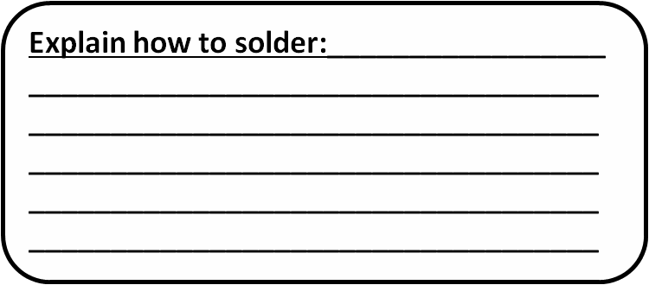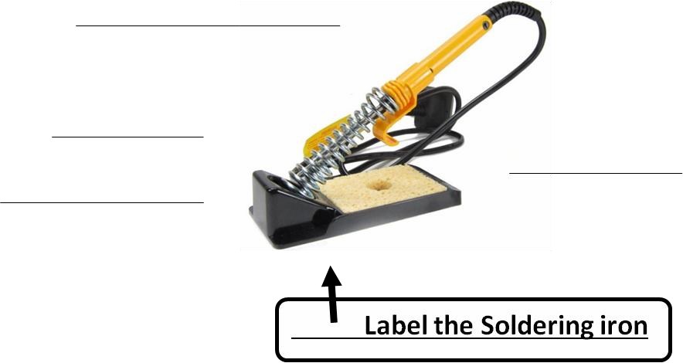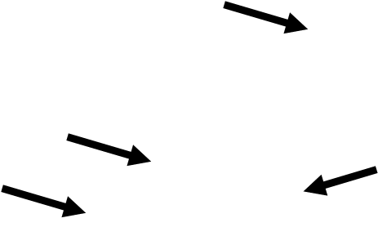

Teachers comment:

Student feedback comment: