Cycle 1 Homework

Subject: Creative iMedia
Year 10

This cycle you are learning: RO81 – Pre Production Skills

Week of cycle
1 | Knowing your target audience
2 | Copyright Laws
3 | Primary & Secondary Research
4 | Hardware & Software used in producing pre-production documents
5 | Mind Maps
6 | Mood Boards
7 | Visualisation Documents
8 | Assessment
9 | Planning your work
Rationale for home work this term:
- To consolidate in class learning
- To secure your knowledge of key topics
- To practice skills related to your assessment

Expectations
- Complete 1 homework task per week.
- Your homework will be peer marked and marked online.
- It must be completed by the due date or you will receive an automatic 60-minute detention.

Name ______________________
Teacher ____________________

Week 1 – Knowing your target audience

Due: Week 2, lesson 3, date: ___________________
Success criteria:
- TBAT identify the target audience for different products.
- TU why knowing who your target audience are is important.
Assessment method:
- Peer Assessment.

Task:
Explain who you think the target audience is for each app.
Age range:

Gender:

Justify your choices:
Age range:

Gender:

Justify your choices:

Age range:

Gender:

Justify your choices:

Explain why it is important to know who your target audience are for the product you are designing.

Week 2 – Copyright Laws

Due: Week 3, lesson 3, date: ___________________
Success criteria:
- TBAT answer all knowledge-based questions.
- TBAT answer revision knowledge-based questions.
Assessment method:
- Online quiz.
Task:
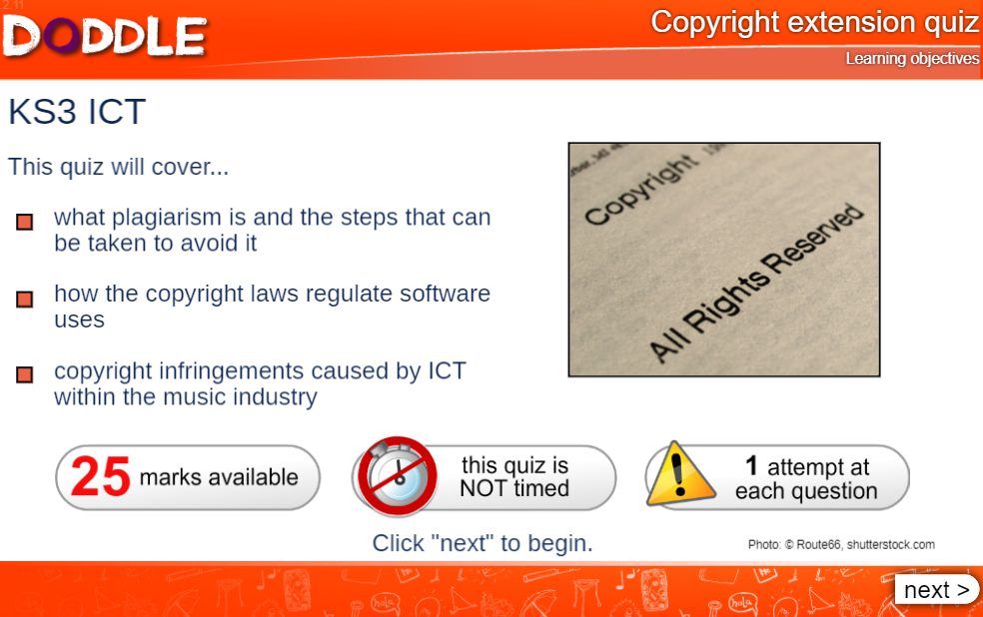 | Score:

Week 3 – Primary & Secondary Research

Due: Week 4, lesson 3, date: ___________________
Success criteria:
- TBAT answer all knowledge-based question.
- TBAT answer revision knowledge-based questions.
Assessment method:
- Peer Assessment

 | Primary Research | Secondary Research
Meaning/
Definition

Time taken
High or Low Cost?
Typical methods used.

Week 4 – Hardware

Due: Week 5, lesson 3, date: ___________________
Success criteria:
- TBAT choose suitable hardware for graphic design tasks.
- TBAT justify your choice of hardware.
Assessment method:
- Peer Assessment.

Research into suitable hardware for a graphic designer, complete the table below:
Hardware | My recommendation for a graphic designer (name of product) | Why I have chosen it (justification)
Tablet & Stylus
Desktop PC
Camera
Printer

Scanner

Graphics Tablet

Week 5 – Mind Maps

Due: Week 6, lesson 3, date: ___________________
Success criteria:
- TBAT create a mind map for a given topic.
Assessment method:
- Peer Assessment.
Task: Create a mind map to show your ideas for a video game aimed at increasing boy’s literacy: (Use words and pictures).

Boy’s literacy computer game
Game play
Activities
Visuals
Levels

Week 6 – Mood Board

Due: Week 7, lesson 3, date: ___________________
Success criteria:
- TBAT create a mood board for a given project.
Assessment method:
- Peer Assessment.
Task: Using various different media, create a mood board for the computer game aimed at increasing boy’s literacy. (Use words and pictures). Include ideas for fonts, colours, characters, backgrounds/worlds, activities.

Week 7 – Visualisation Documents

Due: Week 7, lesson 3, date: ___________________
Success criteria:
- TBAT create a visualisation document for a given project.
Assessment method:
- Peer Assessment
Task: Create a visualisation diagram for a DVD cover for the computer game to increase boy’s literacy. Remember to annotate your diagram to explain and justify the contents of your design.

Week 8 – Revision for the assessment

Due: Week 8, lesson 3, date: ___________________
Success criteria:
- TBAT to revise the content of the RO81 unit that has been covered so far.
Assessment method:
- Peer Assessment

Task: Make a mind map or revision notes to help you revise the content of this unit you have covered so far.

